Student Name: Sahil Hans UID: 25MCI10088
Branch: M.C.A(A.l & M.L) Section/Group: MAM-1 A
Semester: Second Sem Date of Performance:12/01/2026
Subject Name: TECHINCAL SKILLS Subject Code:

WORKSHEET 2
AIM: To design and implement a sample database system using DDL, DML, and DCL commands, including database creation, data manipulation, schema modification, and role-based access control to ensure data integrity and secure, read-only access for authorized users.
S/W Requirement: Oracle Database Express Edition and pgAdmin
OBJECTIVES:
- To retrieve specific data using filtering conditions
- To sort query results using single and multiple attributes
- To perform aggregation using grouping techniques
- To apply conditions on aggregated data
- To understand real-world analytical queries commonly asked in placement interviews
Given:
Practical / Experiment Steps
Step 1: Database and Table Preparation
- Start the PostgreSQL server.
- Open the PostgreSQL client tool.
- Create a database for the experiment.
- Prepare a sample table representing customer orders containing details such as customer name, product, quantity, price, and order date.
- Insert sufficient sample records to allow meaningful analysis.
Querry:
Table Creation:
CREATE TABLE CustomerOrders (
OrderID SERIAL PRIMARY KEY,
CustomerName VARCHAR(50),
Product VARCHAR(50),
Quantity INT,
Price DECIMAL(10,2),
OrderDate DATE
);
Insertion Of Records
INSERT INTO CustomerOrders
(CustomerName, Product, Quantity, Price, OrderDate)
VALUES
('Aarav', 'Laptop', 1, 65000, '2025-01-10'),
('Neha', 'Mobile', 2, 40000, '2025-01-12'),
('Rohit', 'Laptop', 1, 70000, '2025-01-15'),
('Priya', 'Tablet', 3, 45000, '2025-01-18'),
('Karan', 'Mobile', 1, 20000, '2025-01-20'),
('Simran', 'Laptop', 2, 130000, '2025-01-22'),
('Aman', 'Tablet', 2, 30000, '2025-01-25'),
('Riya', 'Mobile', 3, 60000, '2025-01-26'),
('Vikas', 'Laptop', 1, 68000, '2025-01-28'),
('Pooja', 'Tablet', 1, 15000, '2025-01-30');

Output:
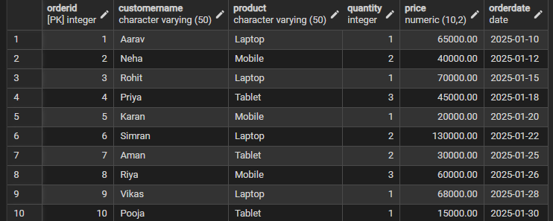

Step 2: Filtering Data Using Conditions
- Execute data retrieval operations to display only those records that satisfy specific conditions, such as higher-priced orders.
Querry(Without case Statment)
SELECT *
FROM CustomerOrders
WHERE Price > 50000;

Querry with case statement:
SELECT *
FROM CustomerOrders
WHERE
CASE
WHEN Price > 50000 THEN 1
ELSE 0
END = 1;
Output:
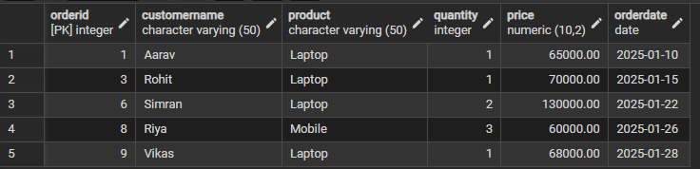
Step 3: Sorting Query Results
- Retrieve selected columns from the table and arrange the output based on numerical values such as price.
- Perform sorting using both ascending and descending order.
- Apply sorting on more than one attribute to understand priority-based ordering.
Querry:
Sort orders by price in ascending order
SELECT *
FROM CustomerOrders
ORDER BY Price ASC;

Output:
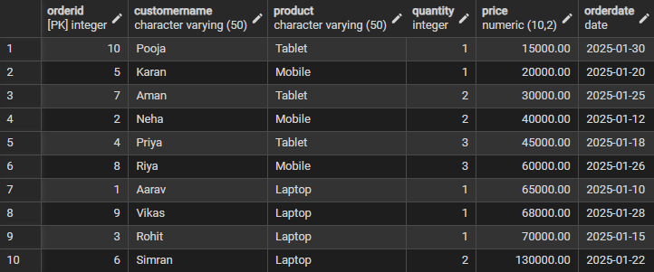

Sort orders by price in descending order
Querry:
SELECT *
FROM CustomerOrders
ORDER BY Price DESC;

Output
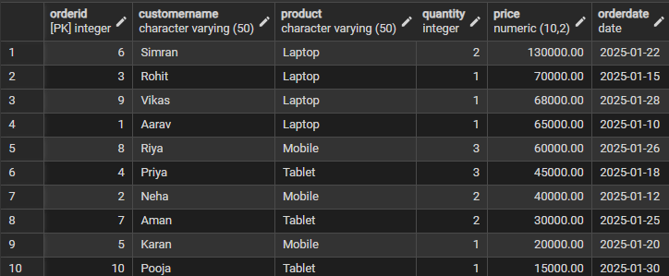

Sort using multiple columns
Querry:
SELECT *
FROM CustomerOrdersORDER BY Product ASC, Price DESC;

Output:
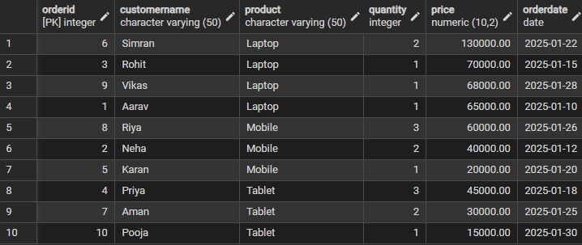

Step 4: Grouping Data for Aggregation
- Group records based on a common attribute such as product.
- Calculate aggregate values like total sales for each group.
Total sales for each product
Querry:
SELECT
Product,
SUM(Price) AS TotalSales
FROM CustomerOrders
GROUP BY Product;

Output
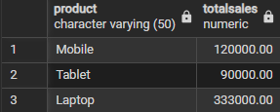
Average price of each product
Querry:
SELECT
Product,
AVG(Price) AS AveragePrice
FROM CustomerOrders
GROUP BY Product;

Output:
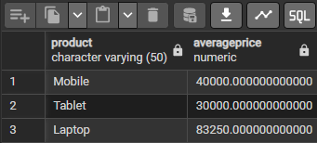
Step 5: Applying Conditions on Aggregated Data
- Apply conditions on grouped results to retrieve only those groups that satisfy specific aggregate criteria.
- Compare the difference between row-level filtering and group-level filtering.
Column-Level / Group-Level Filtering (Using HAVING)
Querry:
SELECT
Product,
SUM(Price) AS TotalSales
FROM CustomerOrders
GROUP BY Product
HAVING SUM(Price) > 100000;

Output:
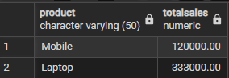
Row-Level Filtering (Using WHERE)
Querry:
SELECT
Product,
SUM(Price) AS TotalSales
FROM CustomerOrders
WHERE Price > 50000
GROUP BY Product;

Output:
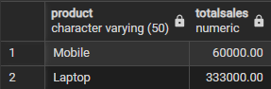
Step 6: Conceptual Understanding of Filtering vs Aggregation Conditions
- Analyze scenarios where conditions are incorrectly applied before grouping.
- Correctly apply conditions after grouping to avoid logical errors.

Incorrect usage:

Querry:
SELECT Product, SUM(Price)
FROM CustomerOrders
WHERE SUM(Price) > 100000
GROUP BY Product;

Correct Usage:

Querry:
SELECT Product, SUM(Price) AS TotalSales
FROM CustomerOrders
GROUP BY Product
HAVING SUM(Price) > 100000;

Output:
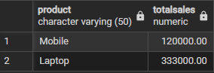

Learning Outcomes:
- Understand how to create relational database tables using appropriate data types and constraints
- Learn to retrieve required data from a table using row-level filtering with the WHERE clause.
- Gain the ability to apply column-level (group-level) filtering using the HAVING clause.
- Develop practical knowledge of using CASE statements for conditional logic in SQL queries.
- Understand the use of aggregate functions such as SUM(), AVG(), and COUNT() for analytical reporting.
- Clearly differentiate between row-level filtering and group-level filtering, and apply them correctly in real-world SQL scenarios.

